Paradise Lets Example Booking Form
This is an example booking form for Paradise Lets. You can easily add your own booking form to your site using Holiday Site Builder.
As you can see you can create PDFs of ant content, including photos.
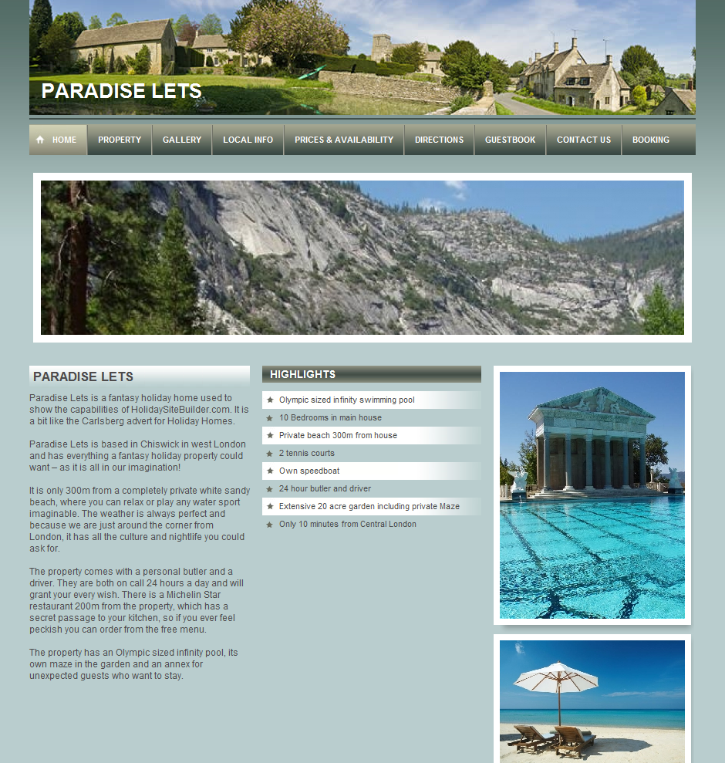
You can upload Word doc and docx documents as well as PDFs.
You can upload up to 20MB, so you can create a pretty huge brochure!

